Theme: One Word: Possibilities!
Take 24 hours out of your busy life and join other women of the ELCA to nurture your body, mind, and spirit as we bring fellowship, songs, Bible studies, and new insights into our lives. This is a retreat for all women: Bring your mother, daughter, granddaughter and/or friends.
55th Annual HON Women’s Retreat at Luther Park, Chetek WI
MONDAY, AUGUST 12th thru TUESDAY AUGUST 13TH.
1 P.M. Registration (Program begins at 1:45 PM) to TUESDAY, AUGUST 13th 1 P.M.
Two Day Registration: $65.00 (Early registration by August 1st)
Monday dinner & snacks and Tuesday breakfast & lunch are included in the registration fee.
$70 .00 (After August 1st) One Day: $35.00 (Fee includes meals/snacks and programming) Breakfast and registration at 8:00 am
Retreat Pastor/Bible Study: Pastor Maggie Isaacson, North Valley Church, Milltown, WI

In-kind gifts for LifeSpring Home: Baby items including diapers, onsies, hygiene products, bottles, etc.
Speaker Judy Espeseth: LifeSpring Home
Music by Sarah Joosten
Music Leaders: Amy Brekke and friends
Bible studies, Holden Service/communion
fellowship, reflection time.

Accommodations are available in modern
duplex cabins; each bedroom sleeps 10 and has its own private bathroom. A lounge is located between the bedrooms.

Bring your Bible, bedding, towels, and personal items. Luther Park is a smoke free/tobacco free campus and is handicapped accessible.

Questions?
Call: Joan Gerland
Retreat Coordinator at 715-205-3100
Email: jlgerland@gmail.com
Bible Verse for the 24 hour Retreat: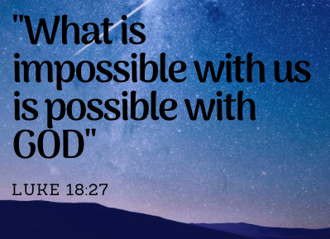

REGISTRATION FORM
Name ______________________________
Address ____________________________
City, Zip ____________________________
E-mail _____________________________
First time attendee? ___________________
Dietary Restrictions? __________________
Please Check :
Two Day Registration: (Before August 1st)
$65 ______
Spending the night? Yes_____ No_____
One Day Registration: $35
Mon___ Tues ____
Eating Breakfast at the retreat?
Yes___ No___
After Aug 1st: Two Day Registration:
$70 _____
Make Check Payable to:
Sandi Gunderson
W/ELCA HON Conference
1003 25 25 ¼ Street
Chetek, WI 54728-7907
arlansandi@gmail.com

