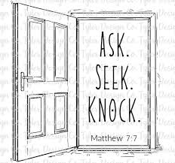2025 WELCA Retreat

Wed. June 4 & Thur. June 5

**ACTIVITIES**



**Chair massage** - $2.00 per minute (10 minute) – pay therapist at appointment – both days

*Sign up needed* and will be at a separate table in the Ministry Center *(look for the sign)*

**Card Making** - $2.50 per card – pay at time of activity to instructor – both days

No sign up needed

**Bookmark** making – Wednesday only – No sign up needed

**Swimming, Kayaking and Canoeing** – both days – No sign up needed

**Pontoon** and **Wagon Rides** – both days – Sign up needed (look for sign in Ministry Center)

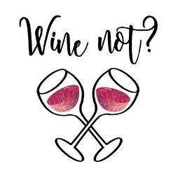

**Chair Yoga** – both days – Sign up needed (look for sign in Ministry Center)

**SIT & SIP** – Wednesday only – No sign up needed

*Enjoy a little wine and relaxation in the beautiful setting of Luther Park Bible Camp*

**Candy Bar BINGO** – Wednesday only – No sign up needed

**KING’S WAY BIBLE & GIFTS**

will have an assortment of Bibles, gifts, apparel, boxed cards, pens,

and fun stuff to purchase - both days.

**Luther Park Bible Camp**

sits on 10 beautiful acres along Prairie Lake in Chetek, Wisconsin.

Their 15 buildings include a Dining Hall, a Chapel, 4 Retreat Facilities,

Indoor Worship Space, 8 Cabins, and offices.

**The offices of the ELCA Synod of Northwest Wisconsin are located at Luther Park as well.**

*Joan Moe, our WELCA Synod President and Bishop Martin Halom will extend greetings.*